**Die Novembergruppe (The November Group, 1918-1934)**

The November Group was an association of radical and politically engaged artists, including painters, sculptors and architects, that was founded in December 1918 in response to the November Revolution in Germany. In contrast to previous such organizations, the group served neither to unite its members in the pursuit or promotion of a particular aesthetic or artistic style nor to pursue the functions of an exhibition society. Its purpose was to unite the creative, forward-looking forces in the fields of art and architecture in order to increase their influence in the shaping of contemporary political and cultural life and reconstruction of the German society after the First World War. The November Group was characterized by the mutual collaboration of its members as well as its professed openness to a wide range of artistic ideas and stylistic methods of expression – a programmatic pluralism, sometimes characterized as “Cubofutoexpressionism” – which provided the group with a generous means for integration and adaptation throughout its existence. The group’s founding manifesto explicitly called on Expressionists, Cubists, and Futurists, but the group also included Dadaists, Constructivists, and later representatives of New Objectivity. The early years of the group’s existence were dominated by expressionist viewpoints; in the 1920s, Constructivism became the dominant artistic movement. In addition to a pronounced pluralism of artistic styles, the active collaboration of painters, sculptors, and architects was part of the program from the group’s very beginning. In 1921, sections for literature and for music were added, leading the November Group, in the 1920s, to become one of the most important forums for new music and experimental film. Between 1919 and 1922, the November Group had regional branches, among them the *Expressionistische Arbeitsgemeinschaft* (Expressionist Working Group) in Kiel, *Kräfte* (Forces) in Hamburg, *Die Kugel* (The Sphere) in Magdeburg, the *Hallische Künstlergruppe* (Halle Artists’ Group), the *Dresdener Sezession “Gruppe 1919”* (Dresden Secession Group 1919), *Das Junge Rheinland* (The Young Rhineland) in Düsseldorf, the Rih group in Karlsruhe, the Üecht group in Stuttgart, and the Dutch De Stijl group, led by Theo van Doesburg.

The group published six issues of its journal *Der Kunsttopf* (The Art Pot) in 1920; a planned publication series conceived by Raoul Hausmann and Hans Siebert von Heister resulted in only one edition, in 1921. The association only held a small number of its own group exhibitions, one in 1919 and one in 1921, both at the Kunstantiquariat Fraenkel & Co in Berlin. Its collaboration with the Italian Futurists, arranged by Filippo Tommaso Marinetti and Enrico Prampolini, led to an exhibition in Rome, in 1920. In 1925, the November Group organized a comprehensive exhibition in the building of the Berlin Secession; on the occasion of its ten-year anniversary, in 1929, it dominated the *Juryfreie Kunstschau Berlin* (Jury-Free Art Exhibition Berlin); and in 1931, it held an exhibition in the new building of the *Verein Berliner Künstler* (Association of Berlin Artists). Of great importance to the group’s presence in Berlin and beyond was its regular participation, between 1919 and 1932, in the *Große Berliner Kunstausstellung* (Great Berlin Art Exhibition), held in the Exhibition Building at Lehrter Bahnhof. In 1922 and 1923, the Polish constructivist Henryk Berlewi, the Russian artist couple Xenia Boguslavskaia and Ivan Puni, and the Russian constructivist El Lissitzky all exhibited in the November Group section at the Great Berlin Art Exhibition. The group’s 1923 presentation included works by Theo van Doesburg and the Hungarian constructivists László Moholy-Nagy and László Peri, as well as paintings by the Romanian artist H. M. Maxy, who had studied with his countryman and November Group member Arthur Segal. In 1925, the presentation included architectural works by a group of architects from Prague, including Bohuslav Fuchs, František Kerhart, Oldřich Starý, Oldřich Tyl, and Jan Víšek. One of the highlights of the November Group’s presentations at the Great Berlin Art Exhibitions in 1927 was the personal exhibition of Kazimir Malevich. The November Group thus was an important platform of the international avant-garde in the 1920s.

References and further reading:

Novembergruppe (ed.), *Der Kunsttopf* (The Art Pot), (1920) 1-6.

*Führer durch die Abteilung der Novembergruppe. Kunstausstellung Berlin 1920* (Guide through the Department of the November Group: Art Exhibition Berlin 1920), exh. cat., Berlin 1920.

Hans-Siebert von Heister and Raoul Hausmann (eds.): *Veröffentlichung der November-Gruppe* (Publication of the November Group), Hannover: Steegemann, 1921.

*Führer durch die Abteilung der Novembergruppe. Kunstausstellung Berlin 1921* (Guide through the Department of the November Group: Art Exhibition Berlin 1921), exh. cat., Berlin: Elsner, 1921.

*Führer durch die Abteilung der Novembergruppe. Kunstausstellung Berlin 1922* (Guide through the Department of the November Group: Art Exhibition Berlin 1922), exh. cat., Berlin 1921.

*Ausstellung Novembergruppe – Malerei, Plastik, Architektur* (Exhibition of the November Group: Painting, Sculpture, Architecture), exh. cat., Berlin: Archiv der Dt. Kunst, 1925.

*Juryfreie Kunstschau Berlin 1929 – Malerei, Graphik, Plastik, Architektur* (Jury-Free Art Exhibition Berlin: Painting, Sculpture, Architecture), exh. cat., Berlin 1929.

*November-Gruppe. Ausstellung im neuen Hause des Vereins Berliner Künstler* (November Group: Exhibition at the new building of the Association of Berlin Artists), exh., cat., Berlin: Porza, 1931.

Will Grohmann (ed.), *Zehn Jahre Novembergruppe* (10 Years of the November Group), Berlin: Klinkhardt & Biermann, 1928.

Helga Kliemann, *Die Novembergruppe* (The November Group), Berlin: Gebr. Mann, 1969.

*Künstler der Novembergruppe* (Artists of the November Group), exh. cat., West Berlin: Galerie Nierendorf, 1985.

Armin Schulz, Annette Ludwig, Anita Beloubek-Hammer (eds.), *Novembergruppe* (November Group), exh. cat., Berlin: Galerie Bodo Niemann, 1993.

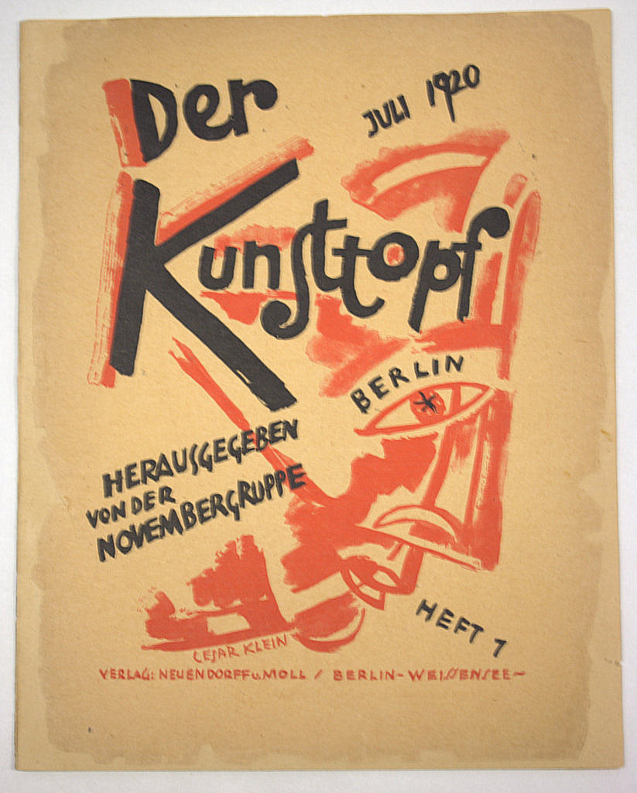

Fig.: Die Novembergruppe, *Der Kunsttopf* (The Art Pot), No. 1, July 1920.